44.58: a) For mass m, in Eq. 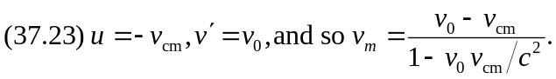
For mass 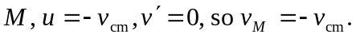b) The condition for no net momentum in the center of mass frame is correspond to the velocities found in part (a). The algebra reduces to 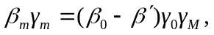where 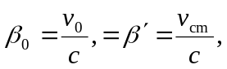and the condition for no net momentum becomes 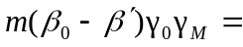
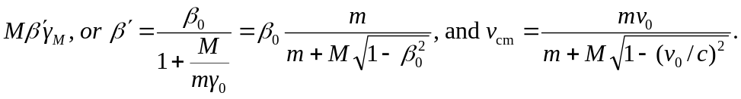
c) Substitution of the above expression into the expressions for the velocities found in part (a) gives the relatively simple forms

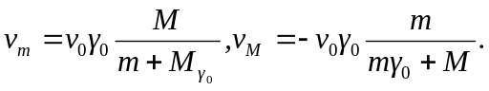
After some more algebra,
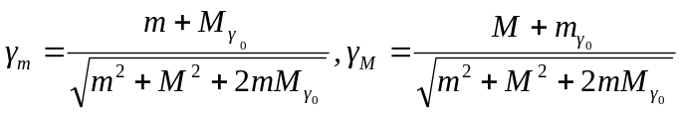, from which 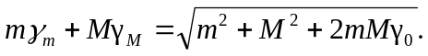
This last expression, multiplied by 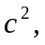 is the available energy 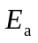in the center of mass frame, so that
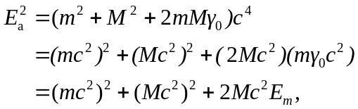
which is Eq. (44.9).

